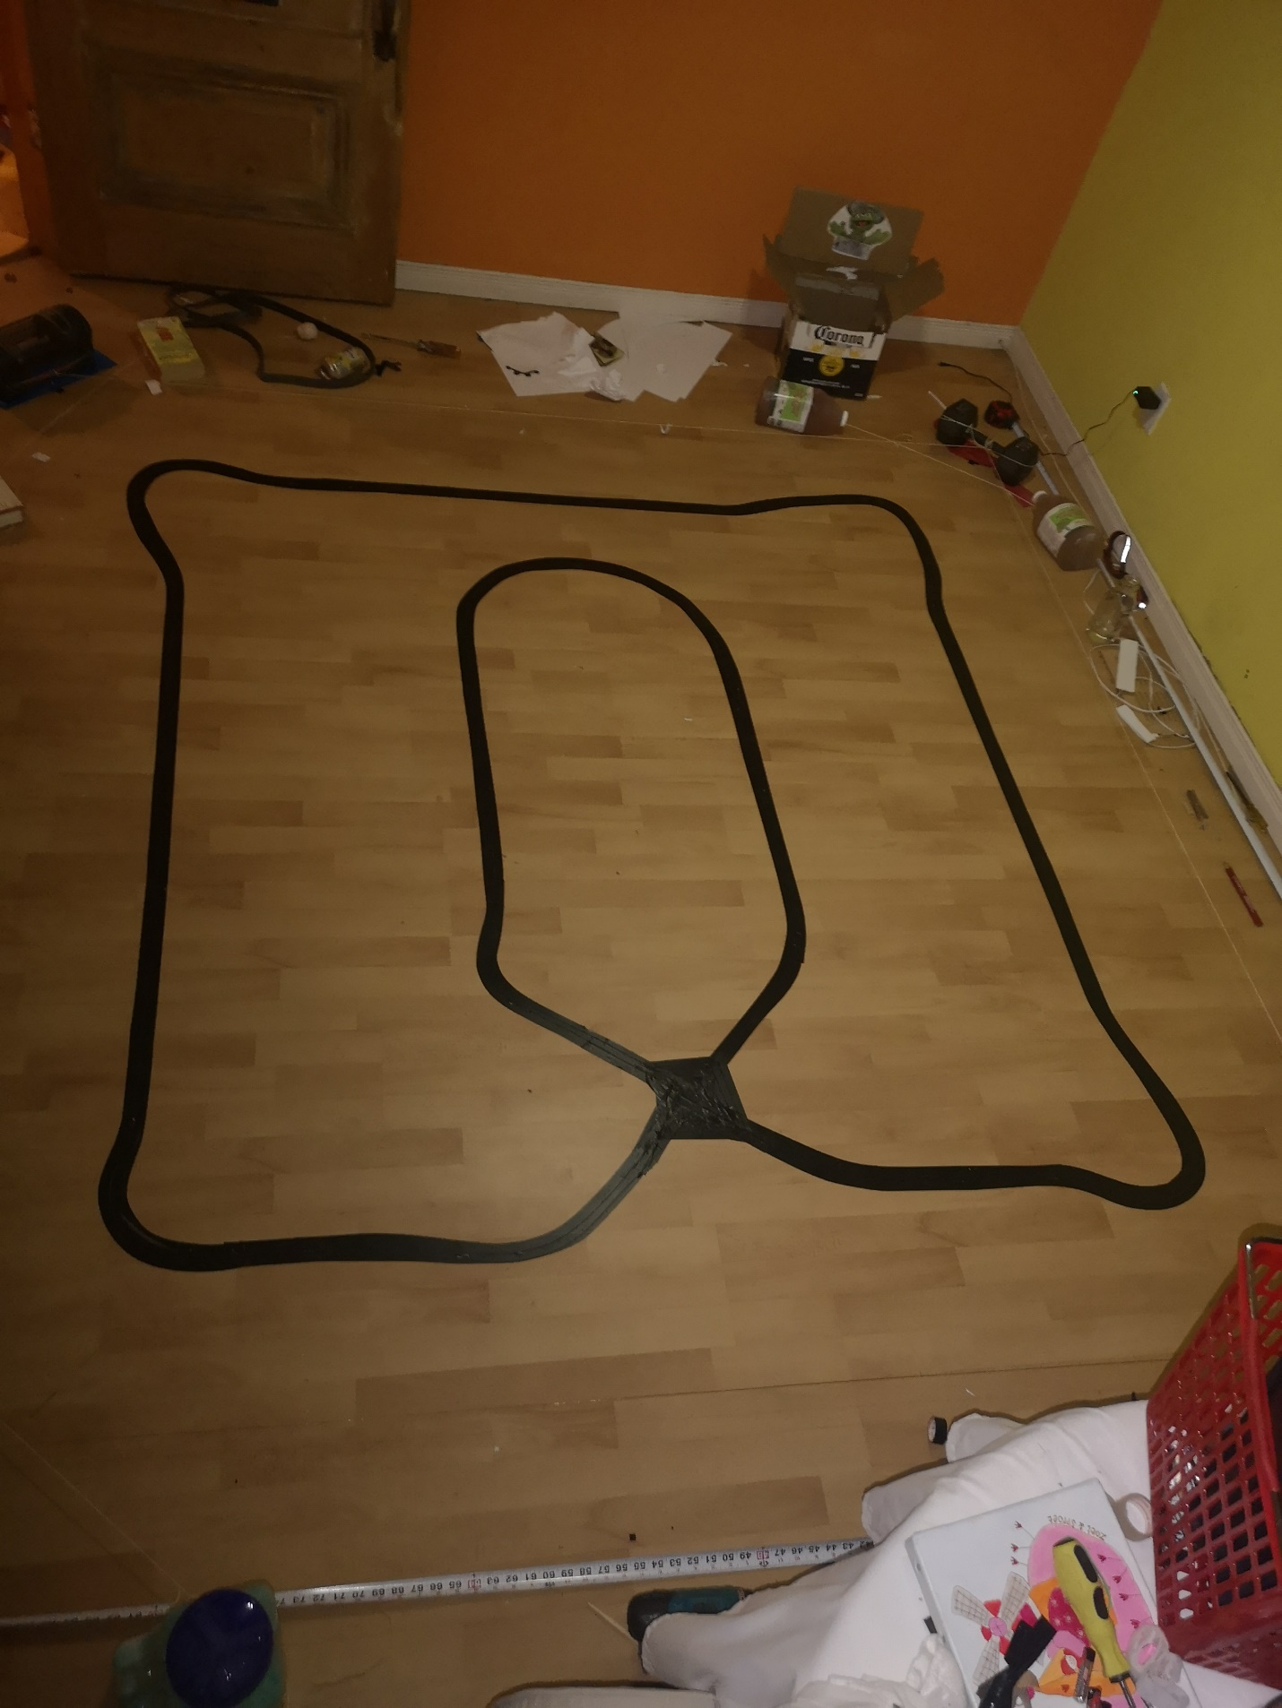

Figure 1: Tape path top view. Origin marked by the star

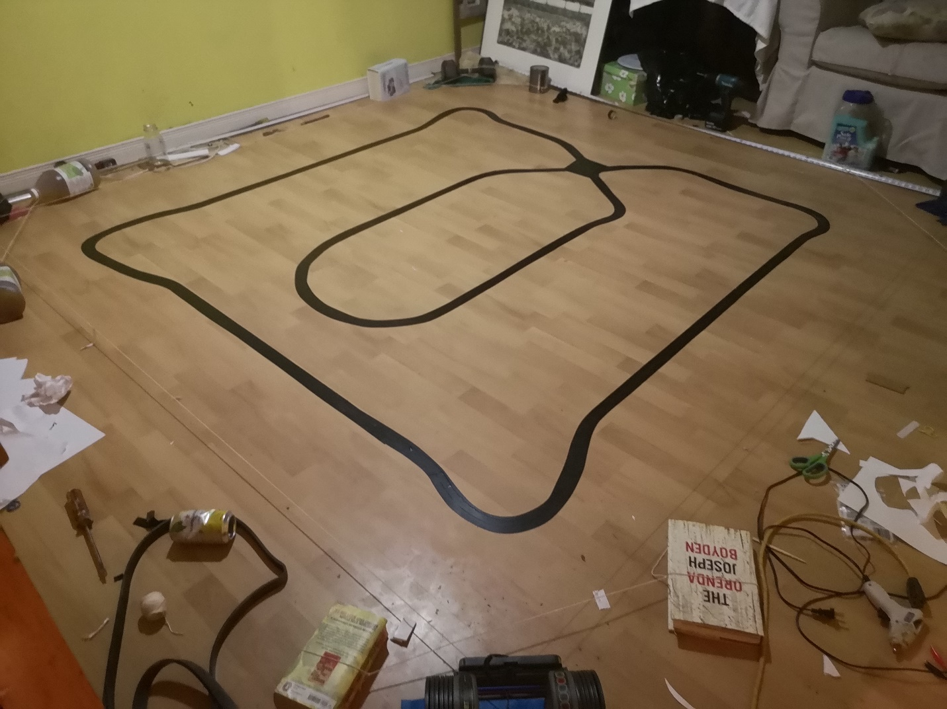

Figure 2: Tape path isometric view. Origin at star

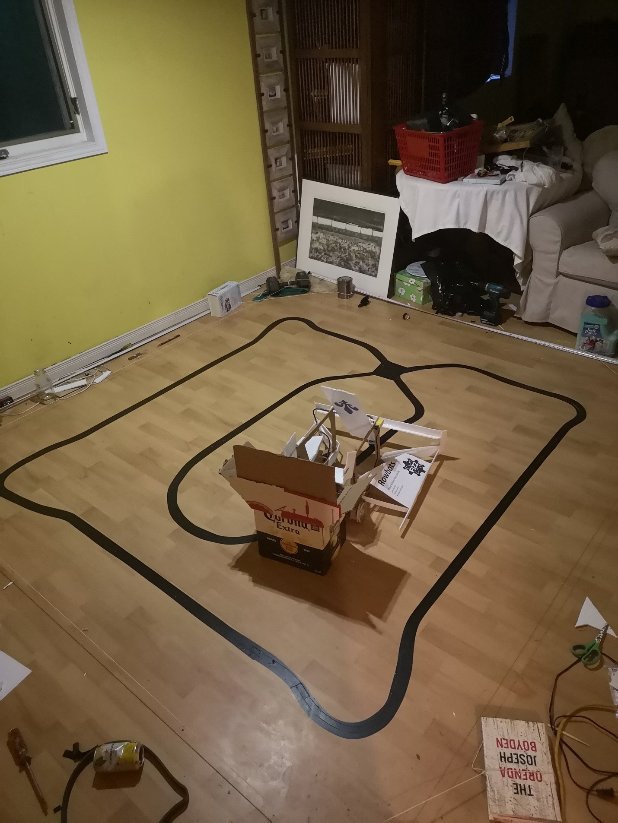

Figure 3: Robot and box start position

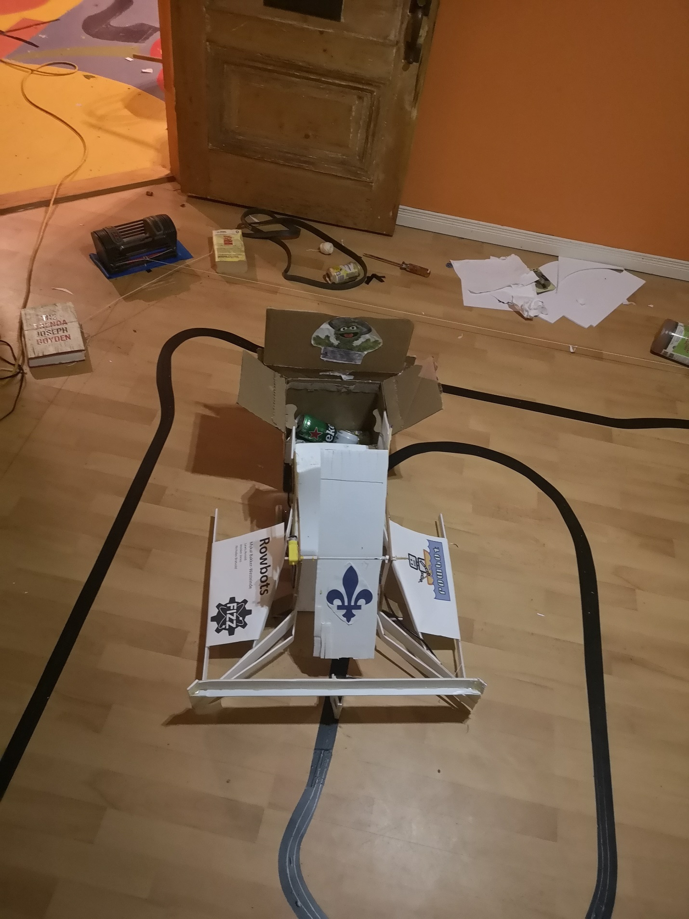

Figure 4: Robot and box start position front view